Snippets of my Power BI work

As Power BI won't let me import the file to you, I decided to show snippets of my work in my own spare time.

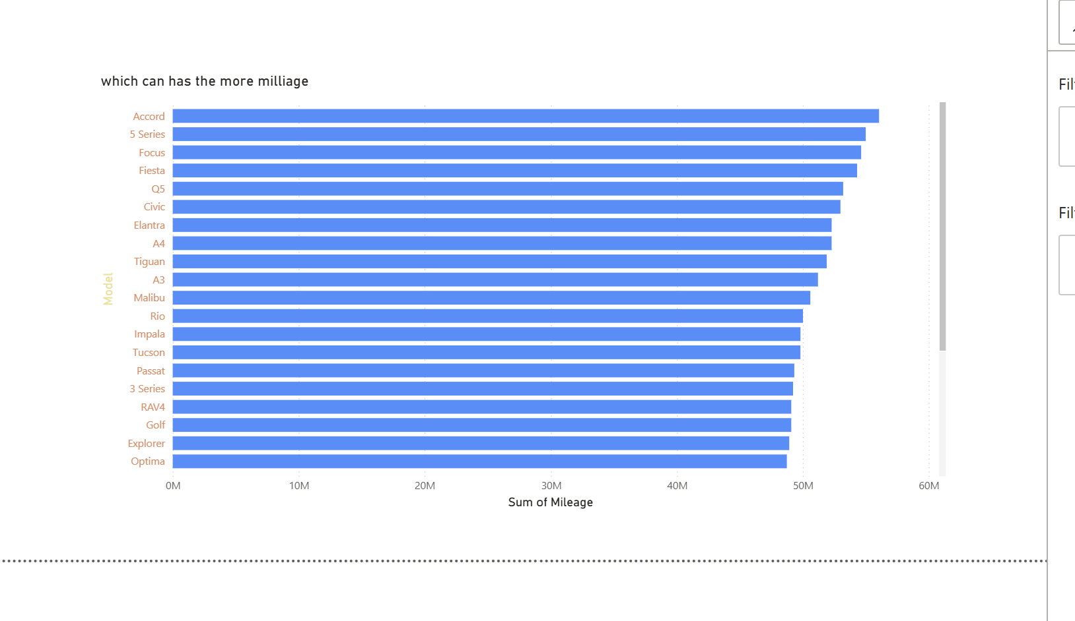

This shows which car has the most mileage. I decided to choose this one as I am interested in cars, and it was quite educational to do as well.

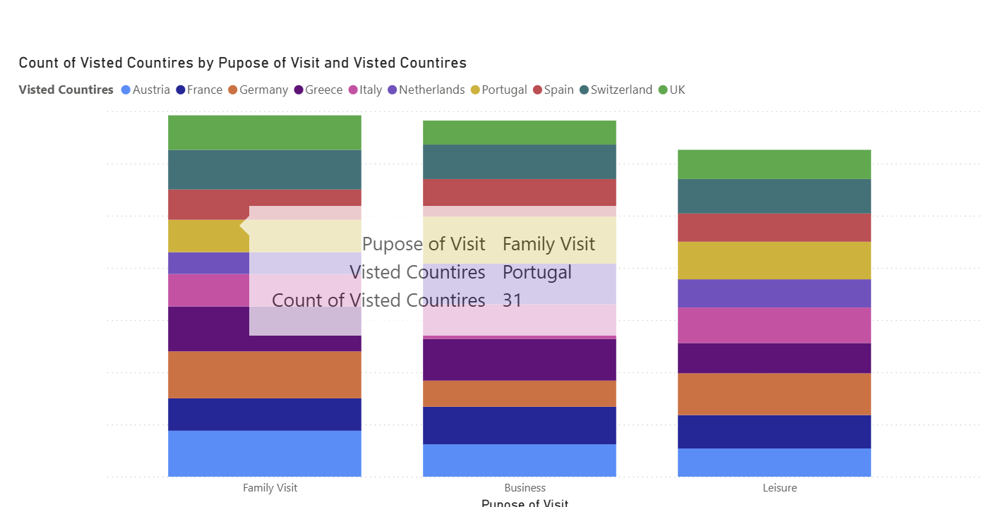

As I like travelling, I also decided to do one about people's visits to different countries.

